* Can swap artifact between environments
  + Eg. V2 is on dev, V1 in prod
  + Warm up V2 on dev by making initial requests to it (so its fast again)
  + Then swap dev and prod
    - Only DNS pointer get swapped, no file is being transferred
    - Now V1 is on dev, V2 on prod
* Swap with preview
  + Pauses before completion so we can verify settings
  + ~test new version of prod, before users see it
  + Then complete/rollback
  + ONLY THING: cannot be used if one of the slots have App Service Authentication enabled
  + ALSO: DB Schema changes: this has to be coordinated by us as well
* Warm up:
  + Deploy to staging
  + App service warms up the app
    - When done, automatically swaps to prod
* Traffic routing
  + Route % of prod traffic to another deployment slot
  + Test features with limited users
    - A/B testing
* NOTE: deployment slots are running on the same infrastructure
  + So, if we want to do load tests on a deployment slot, it should be in a different App Service Plan, so we don’t hog resources from prod

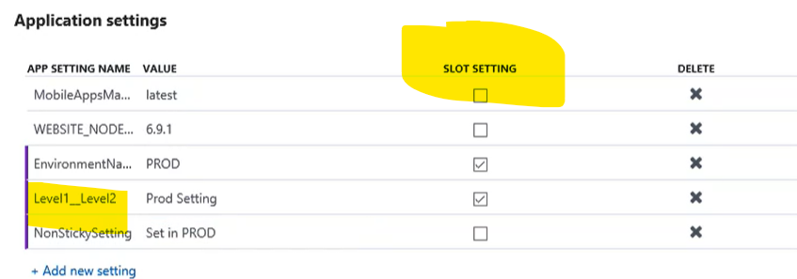

Level1 _ _ Level2: nested JSON objects in appsettings.json

